Bennett Liberty

Landing page URL: BennettLiberty.AcuvueSavings.com

Website URL:

[[https://www.bennetteyecaremidwest.com/](https://www.tvoptometry.com/)](https://www.bennetteyecaremidwest.com/)

[**Phone**](https://www.google.com/search?sxsrf=ACYBGNR1ZpMdYXuMDE8MfyJTtU6HuY1m6w:1570047287293&q=bennett+eyecare+midwest+liberty+phone&ludocid=3507611185363379777&sa=X&ved=2ahUKEwjxs9v2sf7kAhW1IzQIHRq1BtoQ6BMwFnoECBIQAg&sxsrf=ACYBGNR1ZpMdYXuMDE8MfyJTtU6HuY1m6w:1570047287293)**:**[(816) 781-3442](https://www.google.com/search?sxsrf=ACYBGNQlQS1wtLg1dX0amIgpMAZI2cTJJg%3A1570045574567&ei=hv6UXfOPIufB0PEPk6y8KA&q=Eyecare+Midwest+Liberty+MO&oq=Eyecare+Midwest+Liberty+MO&gs_l=psy-ab.3..0i22i30.1258309.1258309..1259530...0.1..0.110.110.0j1......0....2j1..gws-wiz.......0i71.PiNYUKjePwU&ved=0ahUKEwjz6oLGq_7kAhXnIDQIHRMWDwUQ4dUDCAs&uact=5)

– call tracking number to be set up by Ryan/Asher

We need to set up a call tracking phone number to use instead of this one.

We will be running a Click-to-call campaign for this account.

Logo:



### Location & Hours

1504 N Church Rd  
Liberty, MO 64068  
Office Phone: [(816) 781-3442](tel:1-816-781-3442)

[Get Directions](https://goo.gl/maps/rayJeEGECjy)

  Need a ride? Ask us about [Uber](https://m.uber.com/ul/?action=setPickup).

|  |  |
| --- | --- |
| Mon, Wed | 8:30a - 6:00p |
| Tues, Th, Fri | 8:30a - 5:00p |
| Saturday | 8:00a - noon |

Edit to copy block – use generic edit below:

We use advanced diagnostic technology and vision correction products and are committed to improving the your visual quality of life. Give yourself the gift of clear vision – schedule an appointment today.

Dr. Headshots:

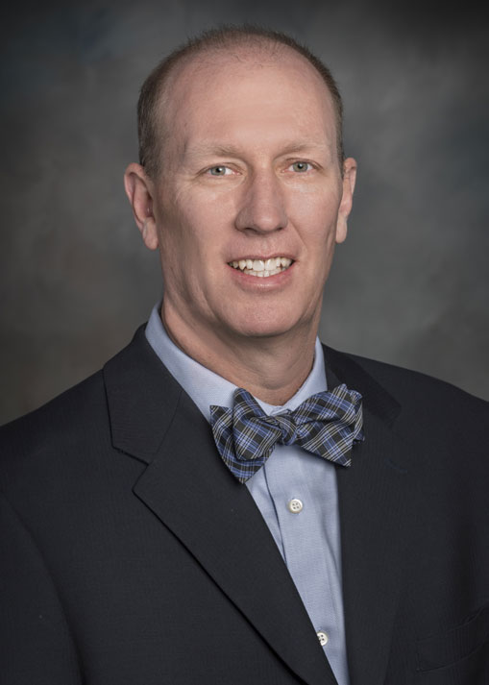

## **Matthew J. Bednar, O.D.**

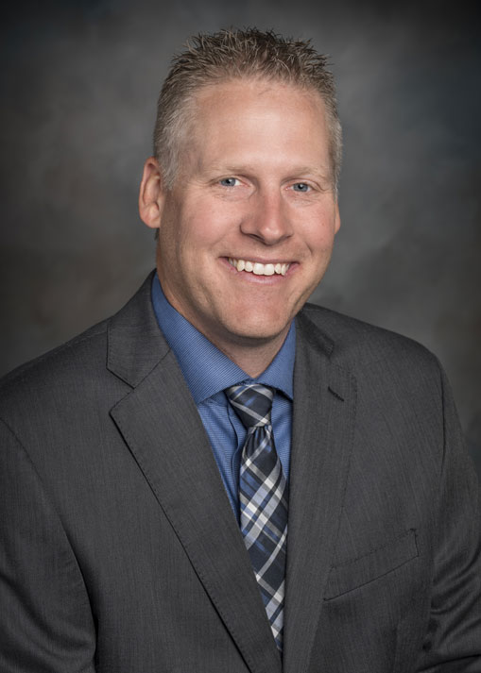

## **David T. Tischinski, O.D.**

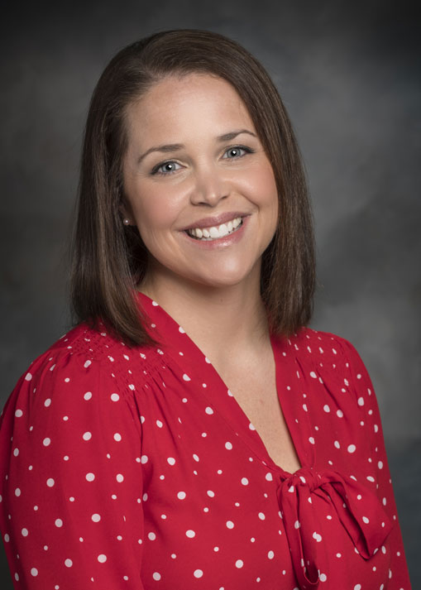

## **Abbie Rondeau, O.D.**

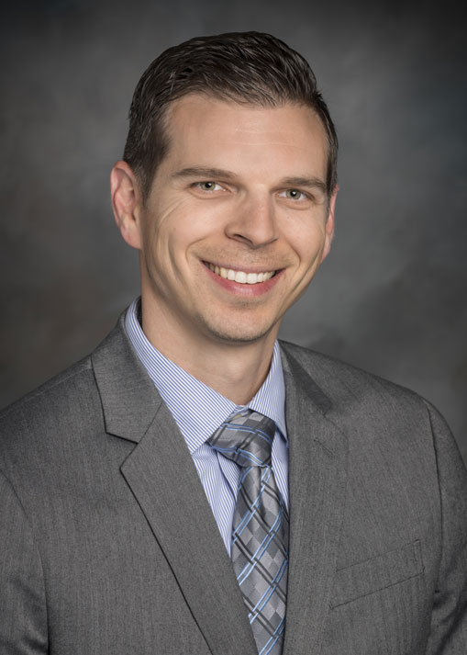

## **Ryan Broyles, O.D.**

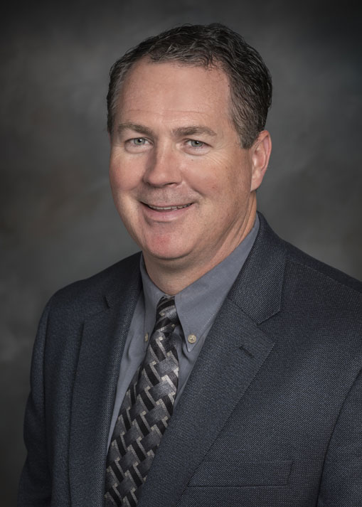

## **David Fritz, O.D.**

[Read more: David Fritz, O.D.](https://www.bennetteyecaremidwest.com/about/meet-our-eye-doctors/162-david-fritz-od)

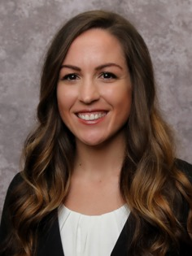

## **Krystal Rogge, O.D.**

Testimonials:

[**Jennifer Duncan**](https://www.google.com/maps/contrib/114791058491510677169/reviews?hl=en-US&sa=X&ved=2ahUKEwjXvrKjsv7kAhVLCTQIHfLgAGcQvvQBegQIARAa)

I love this practice! Dr Tischinski, the front office staff, technicians & 'optical stylists' are is consistently kind, professional and available. Even when I had an eye injury a few years ago, they got me back to seeing clearly quickly.

[**Sara Barton**](https://www.google.com/maps/contrib/110126901700695795554/reviews?hl=en-US&sa=X&ved=2ahUKEwjXvrKjsv7kAhVLCTQIHfLgAGcQvvQBegQIARAh)

Absolutely love this practice... Dr. Fritz takes the time to explain everything. He and his staff are beyond prompt, courteous and patient! He had a very difficult patient and has changed my “view” on life! Thank you Dr. Fritz and staff!

[**marcie masters**](https://www.google.com/maps/contrib/113031602647966247270/reviews?hl=en-US&sa=X&ved=2ahUKEwjXvrKjsv7kAhVLCTQIHfLgAGcQvvQBegQIARA9)

Everyone in this office is top notch friendly, professional and knowledgeable .  
I feel well cared for from the time I arrive to the second I leave. Highly recommend Dr. David Tischinski .

[**Tanya Hirsch**](https://www.google.com/maps/contrib/116373085042600984547/reviews?hl=en-US&sa=X&ved=2ahUKEwjw-oDBsv7kAhVdCjQIHX-qDhwQvvQBegQIARAt)

When we moved to KC we were looking for a quiet, friendly office. This is it. My husband is very picky about his doctor's and he just loves Dr. Rondeau. My daughter saw Dr. Toshinski who was also wonderful. I had a problem once and had to call after hours and was not made to feel troublesome in the least. I just can't say enough good. No complaints.