Bennett North Oak

Landing page URL: BennettNorthOak.AcuvueSavings.com

Website URL:

[[https://www.bennetteyecaremidwest.com/](https://www.tvoptometry.com/)](https://www.bennetteyecaremidwest.com/)

Office Phone: [(816) 454-2020](tel:1-816-454-2020)

– call tracking number to be set up by Ryan/Asher

We need to set up a call tracking phone number to use instead of this one.

We will be running a Click-to-call campaign for this account.

Logo:



### Location & Hours

6080 N. Oak  
Gladstone, MO 64118  
Office Phone: [(816) 454-2020](tel:1-816-454-2020)

[Get Directions](https://goo.gl/maps/Jk7nsy42JrT2)

  Need a ride? Ask us about [Uber](https://m.uber.com/ul/?action=setPickup).

|  |  |
| --- | --- |
| Monday | 8:30a - 6p |
| Tues, Wed, Th | 8:30a - 5p |
| Friday | 8:00a - 5p |
| Saturday | by appt only |

Edit to copy block – use generic edit below:

We use advanced diagnostic technology and vision correction products and are committed to improving the your visual quality of life. Give yourself the gift of clear vision – schedule an appointment today.

Dr. Headshots:

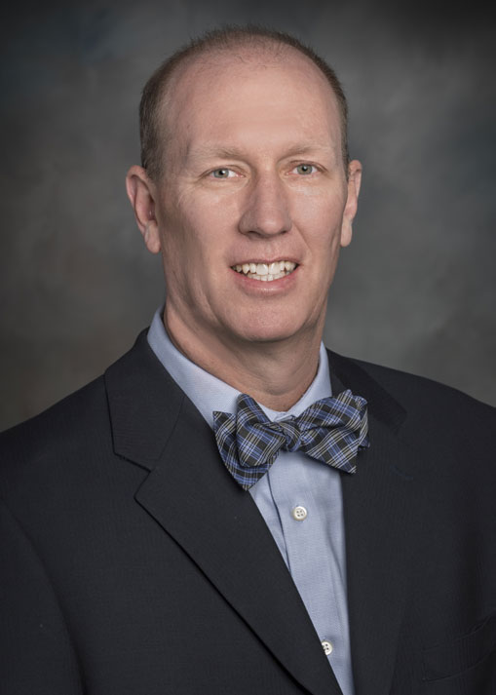

## **Matthew J. Bednar, O.D.**

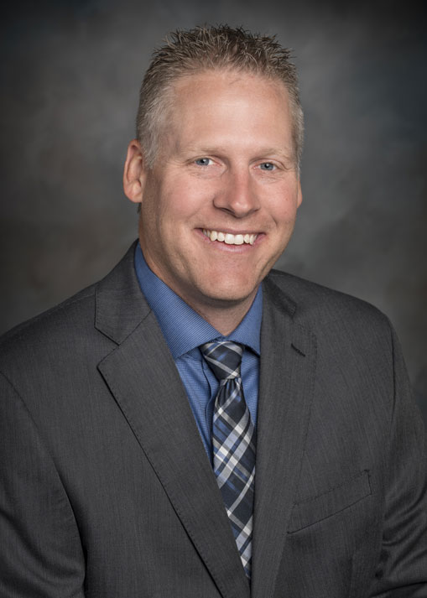

## **David T. Tischinski, O.D.**

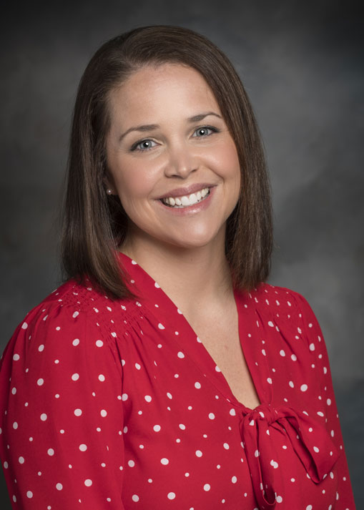

## **Abbie Rondeau, O.D.**

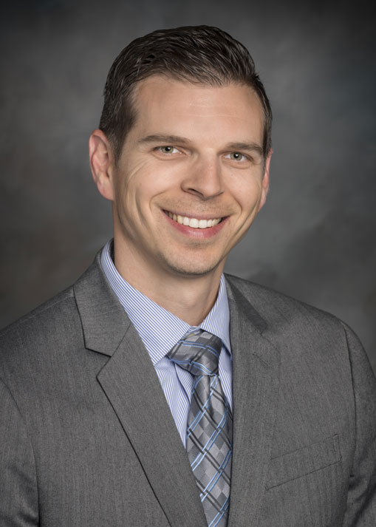

## **Ryan Broyles, O.D.**

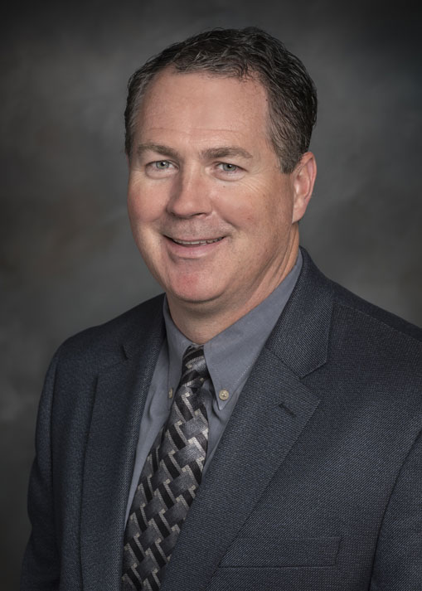

## **David Fritz, O.D.**

[Read more: David Fritz, O.D.](https://www.bennetteyecaremidwest.com/about/meet-our-eye-doctors/162-david-fritz-od)

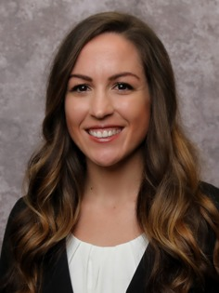

## **Krystal Rogge, O.D.**

Testimonials:

[**John Shafer**](https://www.google.com/maps/contrib/102949289342056218278/reviews?hl=en-US&sa=X&ved=2ahUKEwj06-atsP7kAhVTMn0KHXclAKEQvvQBegQIARAi)

Bennett eye care Midwest on N Oak Trfy is the best eye care shop I've ever been in. The people that work there are so friendly and knowledgeable it's unbelievable! They really care about their clients, and they're so professional. Everything they do has purpose and is done with a great attitude and seemingly no frustration or hesitation.   
They all seem to work well together and they do it with a smile. I'm so glad my Doctor is there. She(Dr Rondeau) is also happy to serve and it shows very much. I can't say enough good things about this group of people or this business.

[**Deborah Buchenau**](https://www.google.com/maps/contrib/103651113883254523875/reviews?hl=en-US&sa=X&ved=2ahUKEwj06-atsP7kAhVTMn0KHXclAKEQvvQBegQIARA4)

Dr. Rondeau takes time to know you and your eye care needs. Exams are thorough and never rushed and technicians are well trained and caring. Personnel responded in a professional manner and questions and messages are answered promptly. The group is a pleasure to work with and I highly recommend them for your eyecare néeds!!!

[**Cynthia Tucker**](https://www.google.com/maps/contrib/103123192744021428419/reviews?hl=en-US&sa=X&ved=2ahUKEwj06-atsP7kAhVTMn0KHXclAKEQvvQBegQIARAT)

I've been a patience of theirs for the last several yrs now, & I have nothing but high praise for this establishment! From the minute you walk in the door, they're very professional & friendly! My optometrist Dr, M Bednar is an excellent & friendly Dr. Not only that, the questions I had, he put me @ ease & explained to me what was going on with my sight ! I have recommended my family & friends to this establishment!