Bennett Blue Springs

Landing page URL: BennettBlueSprings.AcuvueSavings.com

Website URL:

[[https://www.bennetteyecaremidwest.com/](https://www.tvoptometry.com/)](https://www.bennetteyecaremidwest.com/)

(need a responsive website – not mobile friendly)

Office Phone: [(816) 229-3001](tel:1-816-229-3001)

– call tracking number to be set up by Ryan/Asher

We need to set up a call tracking phone number to use instead of this one.

We will be running a Click-to-call campaign for this account.

Logo:



### Location & Hours

3417 NW Mill Dr  
Blue Springs, MO 64015  
Office Phone: [(816) 229-3001](tel:1-816-229-3001)

[Get Directions](https://goo.gl/maps/YDdaGscaLd72)

|  |  |
| --- | --- |
| Mon, Tue, Th, Fri | 8:30a - 5:00p |
| Wednesday | 9:00a - 6:00p |
|  |  |

Edit to copy block – use generic edit below:

We use advanced diagnostic technology and vision correction products and are committed to improving the your visual quality of life. Give yourself the gift of clear vision – schedule an appointment today.

Dr. Headshots:

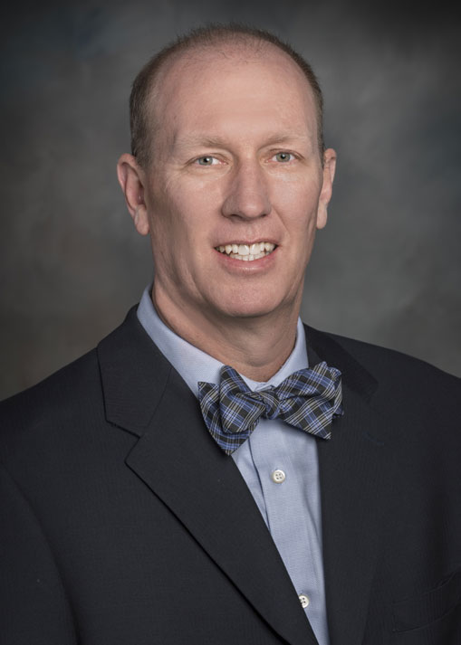

## **Matthew J. Bednar, O.D.**

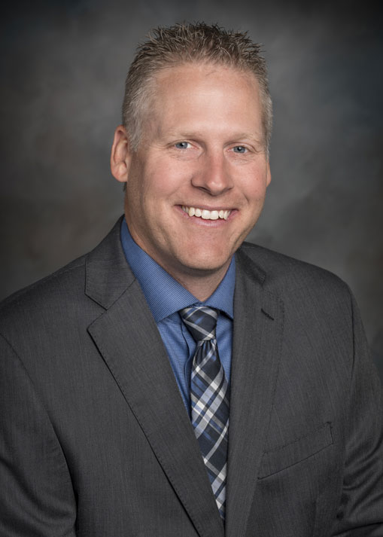

## **David T. Tischinski, O.D.**

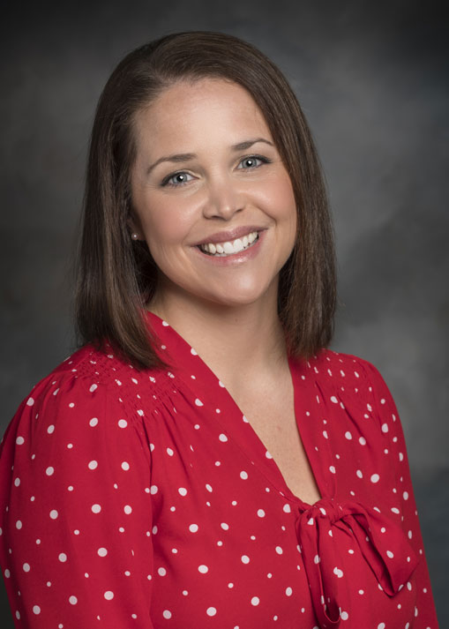

## **Abbie Rondeau, O.D.**

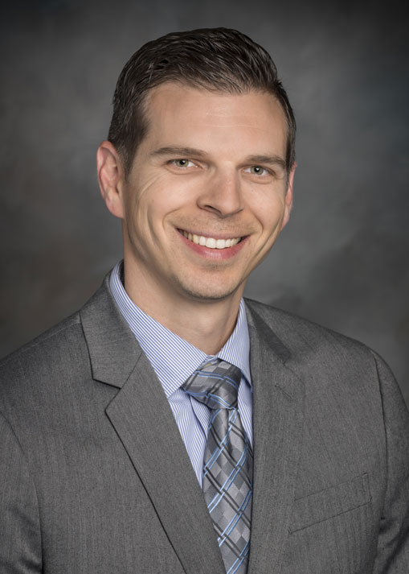

## **Ryan Broyles, O.D.**

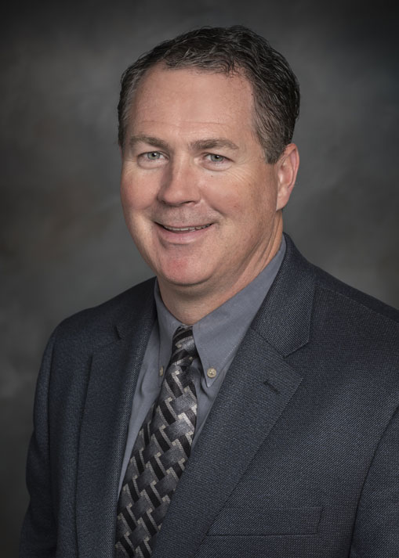

## **David Fritz, O.D.**

[Read more: David Fritz, O.D.](https://www.bennetteyecaremidwest.com/about/meet-our-eye-doctors/162-david-fritz-od)

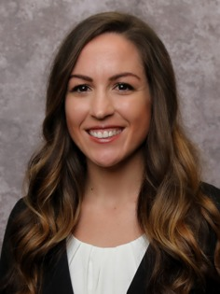

## **Krystal Rogge, O.D.**

Testimonials:

* **[Cody Smith](https://www.google.com/maps/contrib/105152296630952901568/reviews?hl=en-US&sa=X&ved=2ahUKEwjxlMn_rf7kAhVkMH0KHfvkD7sQvvQBegQIARAj)**
* I have been going to Bennett in Blue Springs since they took over the practice and the Doc and all of the staff have been extremely knowledgeable, kind and helpful. They always take the time to be thorough and explain everything. They are always on top of their game with the newest tech and advancements. Doc askes the questions to make sure everything is the best and most effective for my prescription and needs. From my initial scheduling until my contacts or new glasses arrive, they truly work to make everything seamless. It's a level of customer service that used to exist and I hope the trend continues! Thanks for being old school service with new school knowledge and technology.
* [**Jessica Campbell**](https://www.google.com/maps/contrib/112187818734407677520/reviews?hl=en-US&sa=X&ved=2ahUKEwjxlMn_rf7kAhVkMH0KHfvkD7sQvvQBegQIARBB)
* Bennett Eyecare in Blue Springs is a wonderful place to go for eye care. All of the staff is wonderful and they all go above and beyond to help you. We have been going here for years and have always had a good experience. My kids, my husband and myself all come here and have received the help we need. I highly recommend.
* **[Chelsea Staples](https://www.google.com/maps/contrib/101166222850453432203/reviews?hl=en-US&sa=X&ved=2ahUKEwjFsNS8rv7kAhXcHzQIHU_9CRUQvvQBegQIARA8)**
* Everyone is wonderful and kind! They are amazing with my kids and so patient with my daughter in learning to put her contacts in. They are courteous of your time and we love going there!
* [**Scott J.**](https://www.yelp.com/user_details?userid=GYexg8Eyc29I9O4x6I_-yA)
* **Kansas City, MO**

Incredibly friendly staff and doctor, and their pricing on my contacts were less expensive than Costco!