Bennett Platte City

Landing page URL: BennettLiberty.AcuvueSavings.com

Website URL:

[[https://www.bennetteyecaremidwest.com/](https://www.tvoptometry.com/)](https://www.bennetteyecaremidwest.com/)

[**Phone**](https://www.google.com/search?sxsrf=ACYBGNSebADPKjgpnKdEtuxXAb_YgExSoA:1570047715425&q=bennett+eyecare+midwest+-+platte+city+phone&ludocid=4318105025317934360&sa=X&ved=2ahUKEwjlze7Cs_7kAhWPJDQIHbKiC3YQ6BMwE3oECBkQAg&sxsrf=ACYBGNSebADPKjgpnKdEtuxXAb_YgExSoA:1570047715425)**:**[(816) 858-2522](https://www.google.com/search?sxsrf=ACYBGNR1ZpMdYXuMDE8MfyJTtU6HuY1m6w%3A1570047287293&ei=NwWVXbG8EbXH0PEPmuqa0A0&q=Eyecare+Midwest+Platte+City+MO+zip+64079&oq=Eyecare+Midwest+Platte+City+MO+zip+64079&gs_l=psy-ab.12...334875.334875..336492...0.1..0.117.117.0j1......0....2j1..gws-wiz.......0i71.EgCPm_NiIzI&ved=0ahUKEwjxs9v2sf7kAhW1IzQIHRq1BtoQ4dUDCAs)

– call tracking number to be set up by Ryan/Asher

We need to set up a call tracking phone number to use instead of this one.

We will be running a Click-to-call campaign for this account.

Logo:



### Location & Hours

2441 NW Prairie View Rd  
Platte City, MO 64079  
Office Phone: [(816) 858-2522](tel:1-816-858-2522)

[Get Directions](https://goo.gl/maps/ZAEreesdsG22)

  Need a ride? Ask us about [Uber](https://m.uber.com/ul/?action=setPickup).

|  |  |
| --- | --- |
| Mon, Wed, Th, Fri | 8:30a - 5:00p |
| Tuesday | 9:00a - 6:00p |

Edit to copy block – use generic edit below:

We use advanced diagnostic technology and vision correction products and are committed to improving the your visual quality of life. Give yourself the gift of clear vision – schedule an appointment today.

Dr. Headshots:

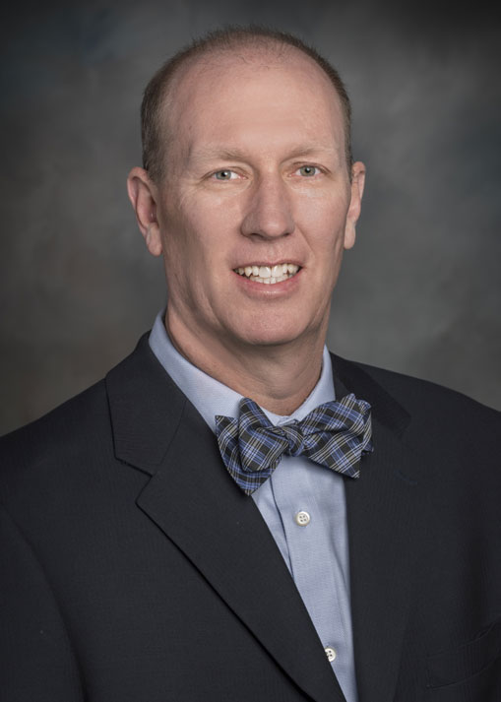

## **Matthew J. Bednar, O.D.**

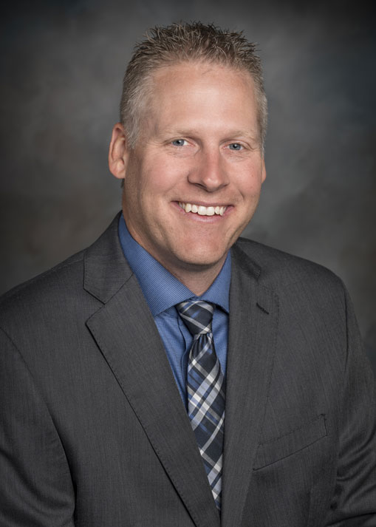

## **David T. Tischinski, O.D.**

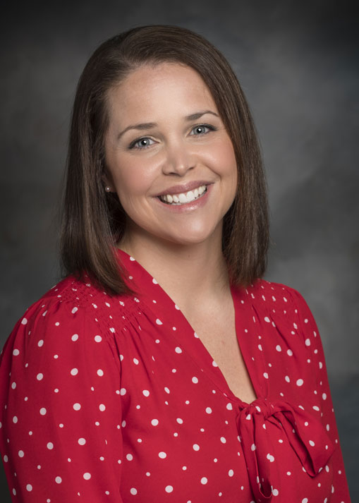

## **Abbie Rondeau, O.D.**

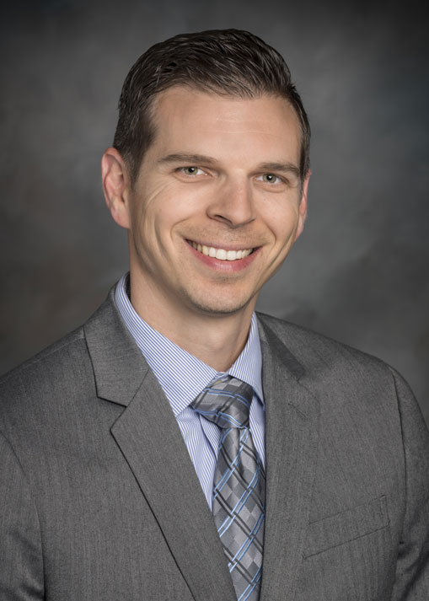

## **Ryan Broyles, O.D.**

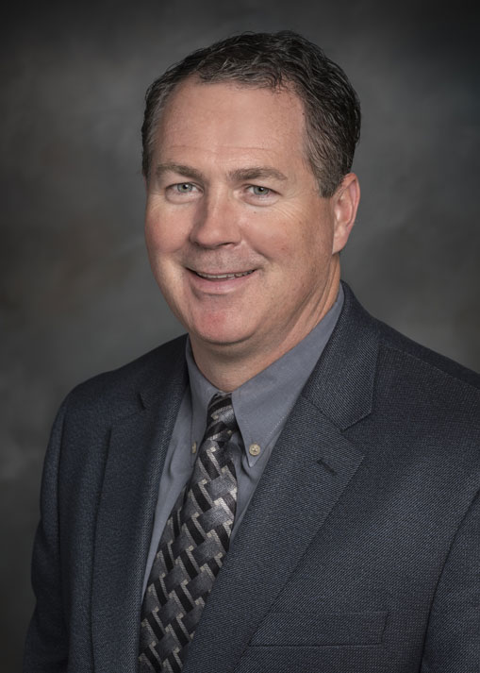

## **David Fritz, O.D.**

[Read more: David Fritz, O.D.](https://www.bennetteyecaremidwest.com/about/meet-our-eye-doctors/162-david-fritz-od)

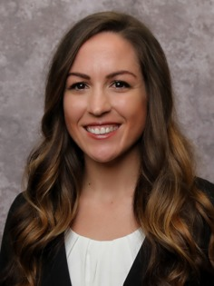

## **Krystal Rogge, O.D.**

Testimonials:

[**Kayla Anne**](https://www.google.com/maps/contrib/100764735390475088462/reviews?hl=en-US&sa=X&ved=2ahUKEwjQrNn1s_7kAhWIHjQIHaLQA64QvvQBegQIARAp)

I have been coming to Bennett Eyecare Midwest in Platte City for years and years. They're always extremely kind, compassionate, and helpful.   
  
Wait times on busy days can sometimes get a bit lengthy, but that's because of how popular they are. Everyone goes out of their way to help as much as possible. They always ask if you need help and are willing to listen to you ramble on about your day.   
  
They offer a wonderful 3D imagery option so you don't have to have your pupils dilated, as well!

[**Erika Criger**](https://www.google.com/maps/contrib/108840926171225626328/reviews?hl=en-US&sa=X&ved=2ahUKEwjQrNn1s_7kAhWIHjQIHaLQA64QvvQBegQIARBB)

I have been coming here for several years now. I've always been really happy with their service. Everyone takes their time with you to answer any questions you have. I've never felt rushed. Everyone is very friendly.

[**vicky seubert**](https://www.google.com/maps/contrib/105102289344853290086/reviews?hl=en-US&sa=X&ved=2ahUKEwjQrNn1s_7kAhWIHjQIHaLQA64QvvQBegQIARAT)

Bennett eye care is great, the staff is very friendly and knowledgeable. Dr. Bednar is great. There is a wide selection of frames to chose from also. I would recommend this place.